Welcome to the Young Adult Group!

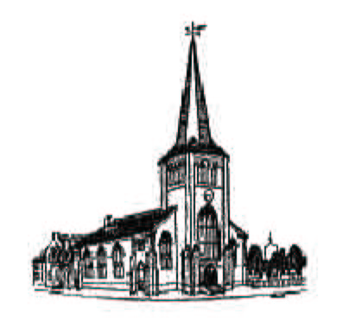

YAG

First Parish in Cambridge
3 Church St.
Cambridge, MA 02138
www.cambridgeyag.org Unitarian-Universalist

We are a welcoming, inclusive and supportive community of young adults (18-35, age centered, but not exclusive to this range) guided by UU principles. With our community as a foundation, our activities serve as a catalyst for personal and spiritual growth. By hosting many events, both planned and spontaneous, we encourage all to share in the joy and passion of exciting friendships and exploration.

Our activities range from social events, volunteering, worship services and much more. Please take a calendar to learn about this month’s activities. A contact person is listed for each event who can give you more info and directions. All events are member initiated, so if there is something you’d like to do, we’d be interested to hear your ideas.

One of the best way to meet members and learn more about us is to join us for lunch. After church each Sunday, we go into Harvard Square and eat outdoors if the weather is nice. Just look for a group of young adults in the social hour where we gather before going to eat.

Further information about YAG, including an online calendar, can be found on our website, www.cambridgeyag.org. Join our list serve where current announcements and info are posted, which you can access through the web site. First Parish’s website, www.firstparishcambridge.org, is a great resource to learn more about our church and community. Please feel free to email us at youngadults@firstparishcambridge.org with any questions.

Thanks for coming and we look forward to getting to know you!!

